6th Class Work
18th - 22nd January

Monday | Tuesday | Wednesday | Thursday | Friday
Maths  Master Your Maths-Week 13  Continue with the next day  Practice your tables (x5) | Maths  Master Your Maths-Week 13  Continue with the next day  Practice your tables (x5) | Maths  Master Your Maths-Week 13  Continue with the next day  Practice your tables (x6) | Maths  Master Your Maths-Week 13  Continue with the next day  Practice your tables (x6) | Maths  Master Your Maths-Week 13  Complete your Friday Test  Practice your tables (Test Yourself x5/x6)
English  Spell It  Learn your next set of spelling words and do the next 2 activities in your spelling book.  Flying High  Read Pg. 48 - 53  Lift Off  Read Pg. 38 | English  Spell It  Learn your next set of spelling words and do the next 2 activities in your spelling book.  Flying High  Pg. 54 Answer  Q A & B  Lift Off  Pg. 39 Answer  Q 3 & 4 | English  Spell It  Learn your next set of spelling words and do the next 2 activities in your spelling book.  Flying High  Read Pg. 57 - 61  Lift Off  Read Pg. 44 | English  Spell It  Learn your next set of spelling words and do the next 2 activities in your spelling book.  Flying High  Pg. 62 Answer  Q A & B  Lift Off  Pg. 45 Answer  Q 3 | English  Spell It  Learn your next set of spelling words and do the next 2 activities in your spelling book.  Flying High  Read Pg. 64 - 67  Lift Off  Pg. 45 Answer  Q 5
PE  5 in a Row | Irish  Clár Áma | S.E.S.E  Science  Bouncy Egg Experiment | S.P.H.E  The power of kindness | Art  Pop Art

P.E: Try for 5 in a row! (Horizontally / Vertically /Diagonally/Or your favourite 5)
Jumping Jacks 1 Minute Rest & Repeat 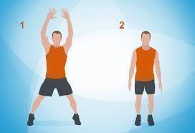 | Cycle Your Bike 15 Minutes (Stay Safe)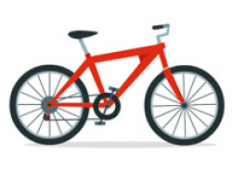 | Dance to 3 of your favourite songs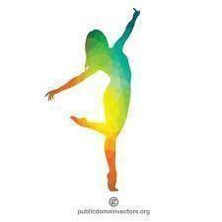 | Jog on the Spot 1 Minute Rest – Complete 3 Times 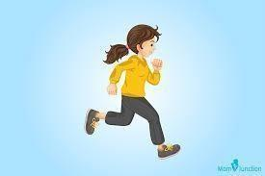 | 10 Arm Dips Rest 10 More 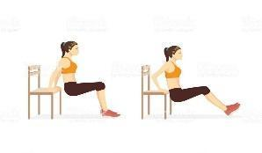
Hold plank position 30 Seconds – Rest 30 Seconds More 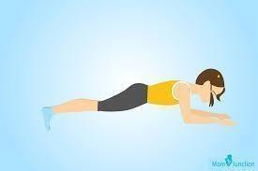 | 20 Mountain Climbs  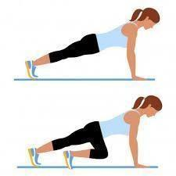 | Go for a walk 15 Minutes 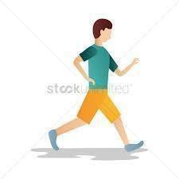 | Crab Walk 1 Minute Crab 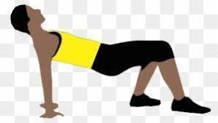 | Sprint 30 Seconds Rest & Repeat 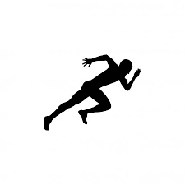
5 Burpees Rest & Repeat 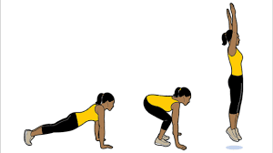 | 10 Press Ups Rest & Repeat 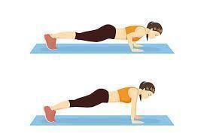 | Create your own obstacle course Complete 3 times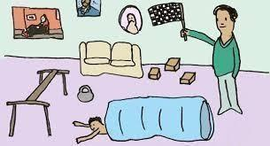 | High Knees 1 Minute Rest & Repeat 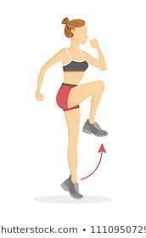 | Bridge Lift Hold for 1 Minute Rest & Repeat  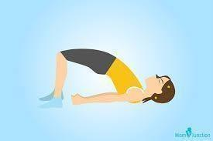
20 Sit Ups Rest & Repeat 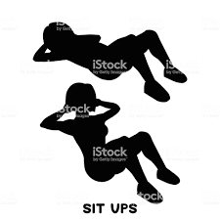 | Play tag/chasing with in the garden 10 Minutes 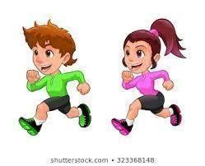 | Hopping Right leg - 1 minute Left Leg - 1 Minute 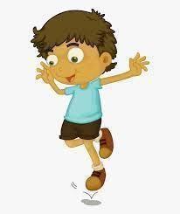 | Down Dog - Hold for 5 breaths Rest & Repeat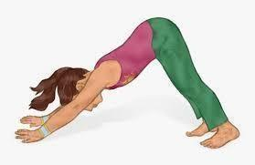 | Lunges 5 with Right Leg 5 with Left Leg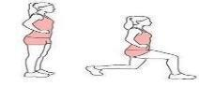
10 Squats Rest & Repeat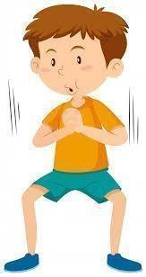 | Skip – 2 Minutes Rest & Repeat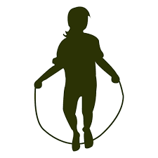 | Skills Practice ( Any Sport) 10 Minutes 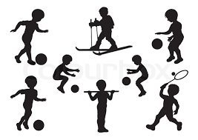 | 10 Crunches Rest & Repeat 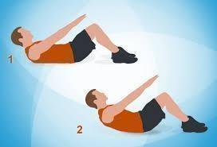 | 10 Windmills Rest & Repeat 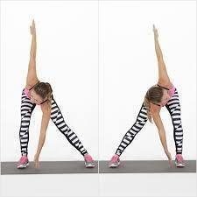

Gaeilge
cartún  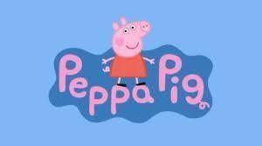 | clár grinn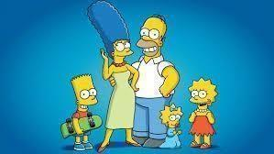 | clár dúlra | trath na gceist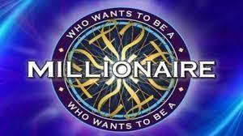
clár spóirt | clár cainte 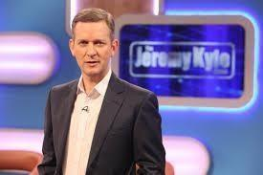 | nuacht | clár ceoil
sobaldráma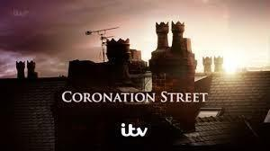 | teilifís réaltachta 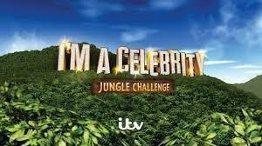 | scannán 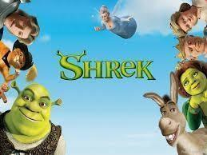 | cúrsaí reatha

- Take a look at all the programmes that you and your family might be watching. Write down what programmes you like, what programmes you don't like and what programmes you prefere. You can use the website www.focloir.ie to help you.
- Activity 1: 👍 Is maith liom ________.
👎 Ní maith liom ________.
👌 Is fearr liom _________.
- Activity 2: (If you need an extra challenge) Write down when the programme is on mar shampla: Tá cartún ar siúl ar a trí a chlog Dé Luain.
S.E.S.E: Science - Bouncy Egg Experiment
You will need: One boiled Egg / White vinegar / Food colouring (Optional) / A Bowl / Cling Film
Method:
- Place the boiled egg in the bowl.
- Cover the boiled egg with vinegar.
- If you would like the finished egg to be coloured, add a few drops of food colouring to the vinegar.
- Cover the bowl with cling film.
- Leave for 3-5 days.
- After 3 days, remove the egg from the bowl and rinse the shell off the egg under a gently running tap.
Results: Think About or Write Your Conclusion
- What do you think the vinegar will do to the egg shell?
- What do you think the vinegar will do to the egg inside the shell?
- Look closely at the egg in the vinegar, what can you see? What does this experiment smell like? Do you like it?
After 3 days.***
- What has happened to the egg shell?
- Can you describe how the egg feels now?
S.P.H.E
This week experience the power of kindness.
- Kindness makes the world a brighter and better place! A big difference can be made to someone's day by acts of kindness as small as ……
😁 Asking someone how they are
😁 Giving a compliment
😁 Offering to help someone
😁 Leaving a kind note for someone
- Try it for a week and see what happens! You can keep track of your kindness by writing down your acts of kindness.
Art 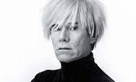
Today you will explore the artist called Andy Warhol.
He was a Pop Artist. He used a technique called screen printing to create lots of prints that look the same.
He often changed the colours of the pictures. He also used very bright colours in his work and repeated images to make patterns.
Andy Warhol made lots of portraits of famous people such as Marilyn Monroe and Elvis Presley.
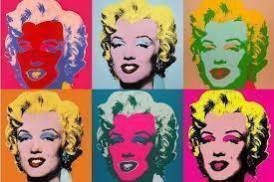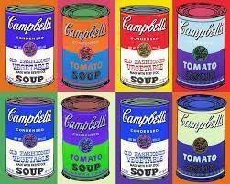
Art Challenge:
- Create your own Andy Warhol inspired picture. Inspire and gather ideas by looking at more of his art work online.
- Use a famous person, family member, an item from the kitchen press or even a repeated symbol to create your own version with colouring pencils, crayons, markers or whatever is available at home to you.

Enjoy the work 😁

