6th Class Work
1st – 5th February

Monday | Tuesday | Wednesday | Thursday | Friday
Maths  Master Your Maths-Week 15  Continue with the next day  Practice your tables (x9) | Maths  Master Your Maths-Week 15  Continue with the next day  Practice your tables (x9) | Maths  Master Your Maths-Week 15  Continue with the next day  Practice your tables (x10) | Maths  Master Your Maths-Week 15  Continue with the next day  Practice your tables (x10) | Maths  Master Your Maths-Week 15  Complete your Friday Test  Practice your tables (Test Yourself x9/x10)
English  Spell It  Week 15  Learn your next set of spelling words and do the next 2 activities in your spelling book.  Ghost, Secrets & thieves  Read pg. 25-27  Lift Off  Read Pg. 26 | English  Spell It  Week 15  Learn your next set of spelling words and do the next 2 activities in your spelling book.  Ghost, Secrets & thieves  Read pg. 28-30  Lift Off  Pg. 27 Answer  Q 3 & 4 | English  Spell It  Week 15  Learn your next set of spelling words and do the next 2 activities in your spelling book.  Ghost, Secrets & thieves  Read pg. 31-33  Lift Off  Pg. 28 Answer  Q6 & 7 | English  Spell It  Week 15  Learn your next set of spelling words and do the next 2 activities in your spelling book.  Ghost, Secrets & thieves  Read pg. 34-36  Lift Off  Pg. 28 Answer  Q 8 | English  Spell It  Week 15  Learn your next set of spelling words and do the next 2 activities in your spelling book.  Ghost, Secrets & thieves  Read pg. 37-39  Lift Off  Pg. 29 Answer  Q 9&10
PE  Shuttle Runs | Irish  Am don léamh lth. 56&57 Q. B | S.E.S.E  European Country Project | S.P.H.E  Things we are grateful for | Art  Self Portrait

P.E
Equipment needed: Jumper/t-shirts/shoes (Anything you can find to use as a cone)

How to play: Lay out 4/5 cones (or anything you can find to use as cones) 5 metres apart (1 metre is approximately one big step) in your garden or in your local park. Try and get someone in your bubble to play with you. Call out a sequence of numbers. For example, 1, 4, 3. You then must run to cone 1 and back, cone 4 and back and cone 3 and back.
After a few minutes try some of the suggestions below to switch it up:
- After you touch the cone run backwards to the start.
- Start from different starting positions like last week.
- Do a bear crawl or skip to the cones.
- Time your shuttle runs and try improve on them

Gaeilge
Léigh an sliocht agus freagair na ceisteanna
Read the piece and answer the questions
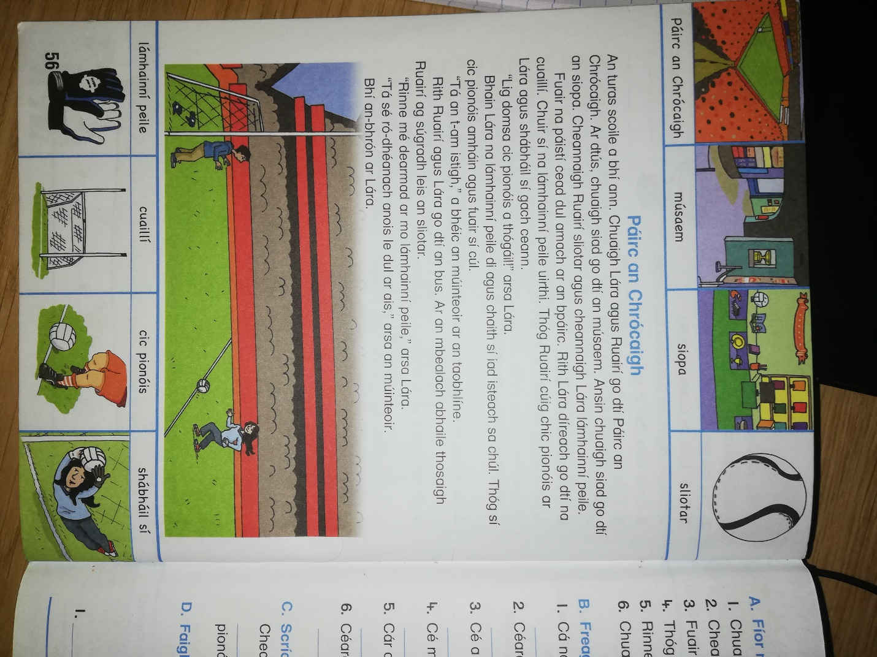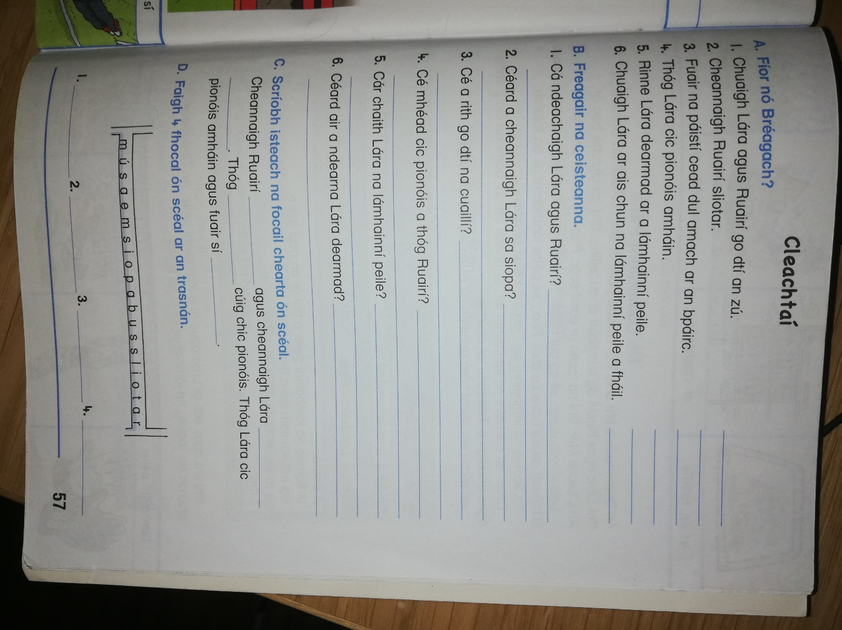

SESE
Choose any European country and do some research for a project. In the project try to cover some of the following:
- The countries population
- The language they speak
- The flag
- Food
- Some history on the country
- Famous landmarks
- Sport in the country
Submit your project to your teacher. We will then choose a winner who will receive a prize of a homework voucher!
S.P.H.E
During this difficult time it’s always easy for us to see the negative side of the situation but today we want you to do the opposite. Write a list of between 5-10 things that you are grateful for or things that are positive about your life at the moment. Here are some examples that might help:
- I am grateful to be able to spend more time with my family
- I am grateful for technology because I can still stay in contact with my friends.
- It’s great to be able to spend more time baking.

Now try and come up with your own. Making a conscience effort to see the positives in a difficult time can be a huge help to your mental health!

Art
Today you will be drawing a self-portrait. Below I have attached a step-by-step guide to help you draw a picture of yourself!
https://artprojectsforkids.org/how-to-draw-a-boy/
https://artprojectsforkids.org/how-to-draw-a-girl/

If you would prefer to create your self-portrait without using the guide that’s okay too. If you have a mirror this can be helpful too!

