6th Class Work
25th – 29th January

Monday | Tuesday | Wednesday | Thursday | Friday
Maths  Master Your Maths-Week 14  Continue with the next day  Practice your tables (x7) | Maths  Master Your Maths-Week 14  Continue with the next day  Practice your tables (x7) | Maths  Master Your Maths-Week 14  Continue with the next day  Practice your tables (x8) | Maths  Master Your Maths-Week 14  Continue with the next day  Practice your tables (x8) | Maths  Master Your Maths-Week 14  Complete your Friday Test  Practice your tables (Test Yourself x7/x8)
English  Spell It  Learn your next set of spelling words and do the next 2 activities in your spelling book.  Ghost, Secrets & thieves  Read pg. 15-16  Lift Off  Read Pg. 20 | English  Spell It  Learn your next set of spelling words and do the next 2 activities in your spelling book.  Ghost, Secrets & thieves  Read pg. 17-18  Lift Off  Pg. 21 Answer  Q 3 & 4 | English  Spell It  Learn your next set of spelling words and do the next 2 activities in your spelling book.  Ghost, Secrets & thieves  Read pg. 19-20  Lift Off  Read Pg. 56 | English  Spell It  Learn your next set of spelling words and do the next 2 activities in your spelling book.  Ghost, Secrets & thieves  Read pg. 21-22  Lift Off  Pg. 57 Answer  Q 3 | English  Spell It  Learn your next set of spelling words and do the next 2 activities in your spelling book.  Ghost, Secrets & thieves  Read pg. 23-24  Lift Off  Pg. 57 Answer  Q 5
PE  Reaction races | Irish  Bris an Cód | S.E.S.E  Interviews | S.P.H.E  Belly Breathing Mindfulness | Art  Everyday object doodling

P.E
Equipment needed: Two jumpers or two t-shirts

How to play: Lay out two jumpers ten metres apart in your garden or in your local park. Invite someone in your bubble to shout “GO”. Get up and sprint from the following positions:
- Lying on your tummy
- Lying on your back
- Sitting on your bum
- Kneeling on the ground
Which one of these positions do you sprint the fastest from?

Gaeilge
Bris an Cód
Break the code! Find out what is written in each section by matching the numbers with letters.
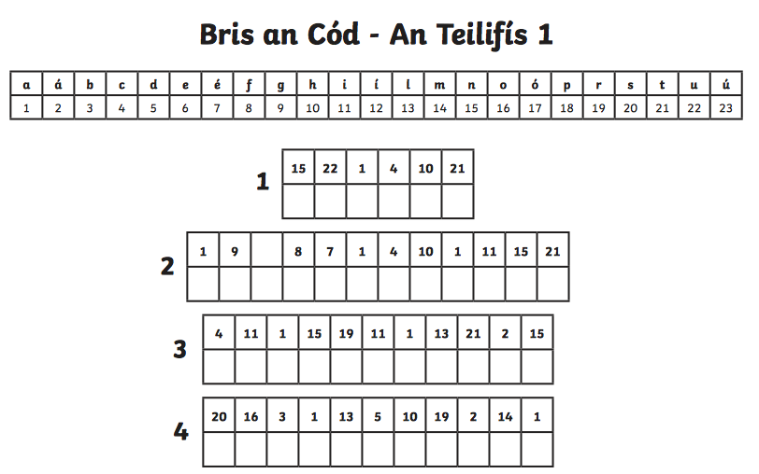

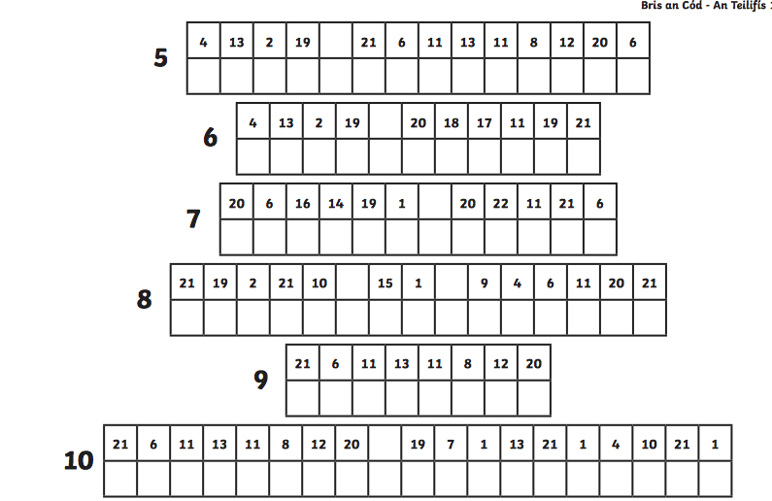

SESE
- Learning about our past. Ask your grandparent or parent can you interview them for 10 minutes to discover what life was like when they were younger. Here are some interview questions you can ask them-
  - What was your favourite toy when you were a child?
  - What was your favourite food?
  - Did you enjoy school? Why/Why not?
  - How did you get to school?
  - What are the main differences between a child’s life back then and a child’s life now?
(If you can think of more questions, ask them!)

- Using the information from your interview, write down how much you think life has changed from when your parent/grandparent was your age. Remember to explain why you think it is different.

(If you are not living with your grandparents, ask them can you zoom/facetime/skype or just give them phone call)

S.P.H.E
Let’s practice some mindfulness
Sit up nice and straight on a chair or on your bed. Breathe for one minute. What do you notice about your breath? Most people will feel themselves breathing from their chest.
Next, place one hand on your belly and one on your chest. Challenge yourself to breathe using your belly. You should feel your hand move out when you breathe in, and in when you breathe out. The hand on your chest should be still.
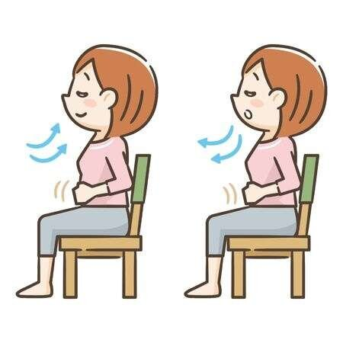
Practice this ‘belly breathing’ for 1 minute. Write down how you feel after this activity.

Art
Today you will let your creativity go wild!
Go on a scavenger hunt in your house and find as many small, everyday items as possible. You can use anything like a shell, a paperclip, coins, a pen, a spoon etc.
Grab a piece of paper and pencil, lay down your objects and draw a picture using your items. Be as creative as possible!
Have a look at these versions for some inspiration:
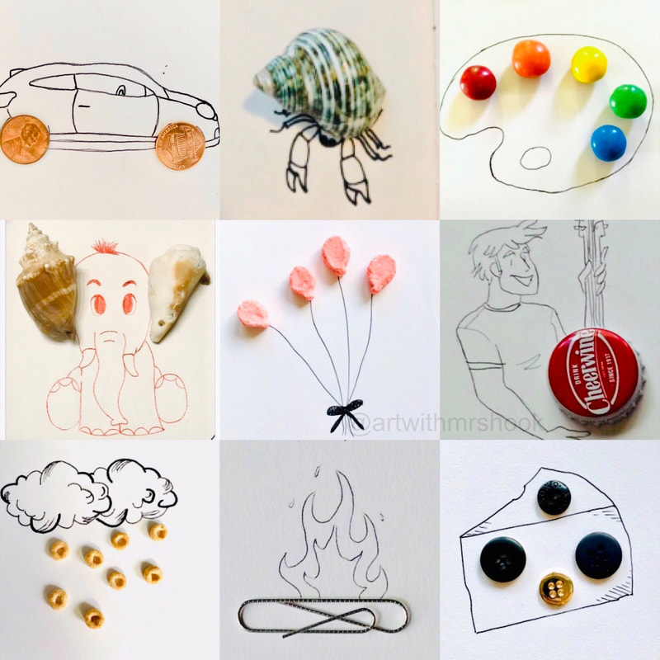

.

Enjoy the work 😁

