6th Class Work
8th - 12th February

Monday | Tuesday | Wednesday | Thursday | Friday
Maths  Master Your Maths-Week 16  Continue with the next day  Practice your tables (x11) | Maths  Master Your Maths-Week 16  Continue with the next day  Practice your tables (x11) | Maths  Master Your Maths-Week 16  Continue with the next day  Practice your tables (x12) | Maths  Master Your Maths-Week 16  Continue with the next day  Practice your tables (x12) | Maths  Master Your Maths-Week 16  Complete your Friday Test  Practice your tables (Test Yourself x11/x12)
English  Spell It  Learn your next set of spelling words and do the next 2 activities in your spelling book.  Ghost, Secrets & thieves  Read pg. 40-42  Lift Off  Pg. 30 Answer  Q 14 | English  Spell It  Learn your next set of spelling words and do the next 2 activities in your spelling book.  Ghost, Secrets & thieves  Read pg. 43-46  Lift Off  Pg. 30 Answer  Q 15 | English  Spell It  Learn your next set of spelling words and do the next 2 activities in your spelling book.  Ghost, Secrets & thieves  Read pg. 47-49  Lift Off  Pg. 30 Answer  Q 16 | English  Spell It  Learn your next set of spelling words and do the next 2 activities in your spelling book.  Ghost, Secrets & thieves  Read pg. 50-52  Lift Off  Pg. 32 Read | English  Spell It  Learn your next set of spelling words and do the next 2 activities in your spelling book.  Ghost, Secrets & thieves  Read pg. 53-56  Lift Off  Pg. 33 Answer  Q 3
PE  Heads or Tails | Irish  Nuair a Fhásaim Suas | S.E.S.E  History Makers | S.P.H.E  Every Cloud has a Silver Lining | Art  Zentangle

P.E
- Try this Flip a coin challenge! Do five rounds.. then repeat for an extra challenge! Good Luck!
Round | Heads | Tails
1 | 15 Jump Squats | 20 sit ups
2 | 60 jog in place | 10 push ups
3 | 20 kneeling push-ups | 20 crunches
4 | 20 jumping jacks | 40 arm circles
5. | 40 high-knees | 1 minute run in place

Gaeilge
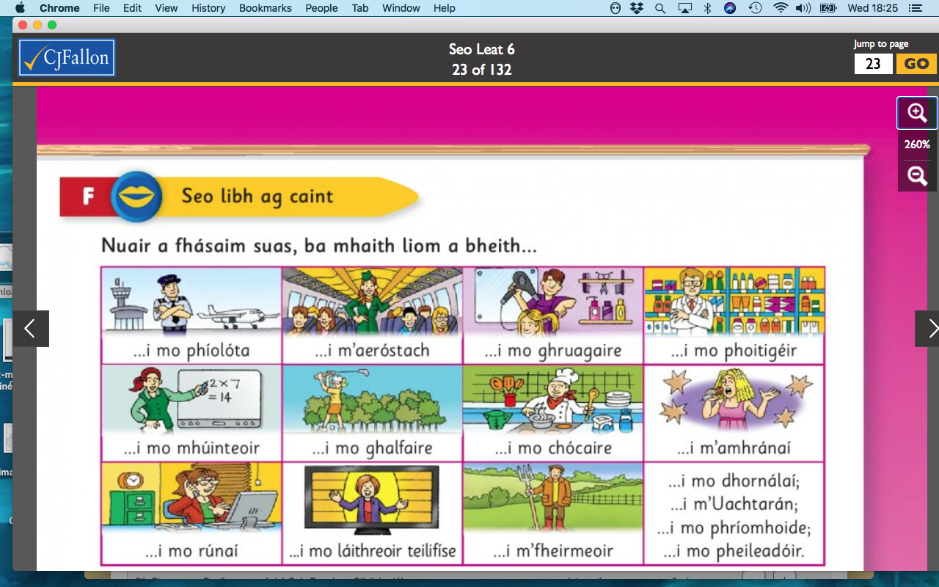
Nuair a fhásaim suas (When I grow up)

Mar Shampla:
- Beidh mise i mo mhúinteoir nuair a fhásaim suas.
(I will be a teacher when I grow up)
Féach ar an bpictiúr agus scríobh na habairtí (Look at the picture and write the sentences)
- Beidh mise ______________ nuair a fhásaim suas.

SESE

We are
History Makers

You are living through history right now. They will be writing about this pandemic in History books in years to come. It’s only February but let’s look at what has happened in 2021 so far…. Covid 19, Attack on Capitol Hill, New President of the U.S.A!
Create your page that you would insert into a History Book. If you can research what has happened so far include dates, a brief summary of the headlines and if you can include pictures that would be amazing!
If you can’t find too much information about 2021 create your page for the year 2020. It was one to remember and forget all at the same time!

S.P.H.E
Every Cloud has a Silver Lining

There is something good in every situation! It is your job to find it. Write 3 things you are finding difficult and try and think of the positive silver lining.
Example: I can’t see my friends at the moment because I’m stuck at home.

But being apart from them makes me realise how much I value our friendship.

Art
Zentangle
Try a new concept called Zentangle. A Zentangle is a miniature abstract work of art created by a collection of patterns. All you need is a pencil, piece of paper and black marker (if you have one)!
Steps
- Using a pencil, put a small dot in each of the corners of your paper.
- Connect the dots with a line, not necessarily a straight one though.
- Using the pencil, sort of “scribble” in some lines, going this way and that, until you have created several spaces on the paper.
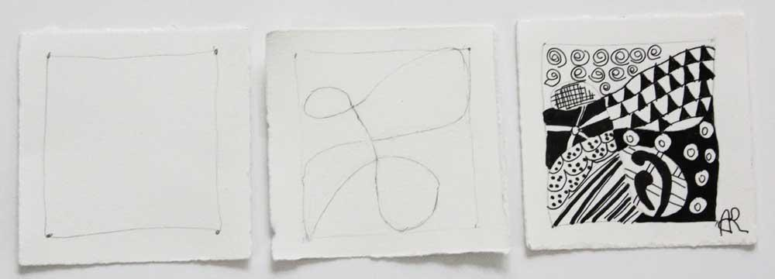
- Using your black pen, create a different pattern in each one of the spaces that you have drawn with your pencil.
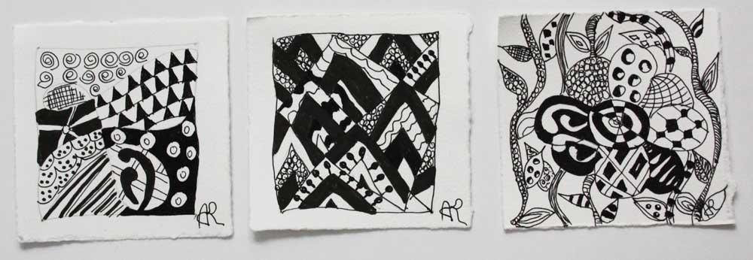
A few more examples for you all:
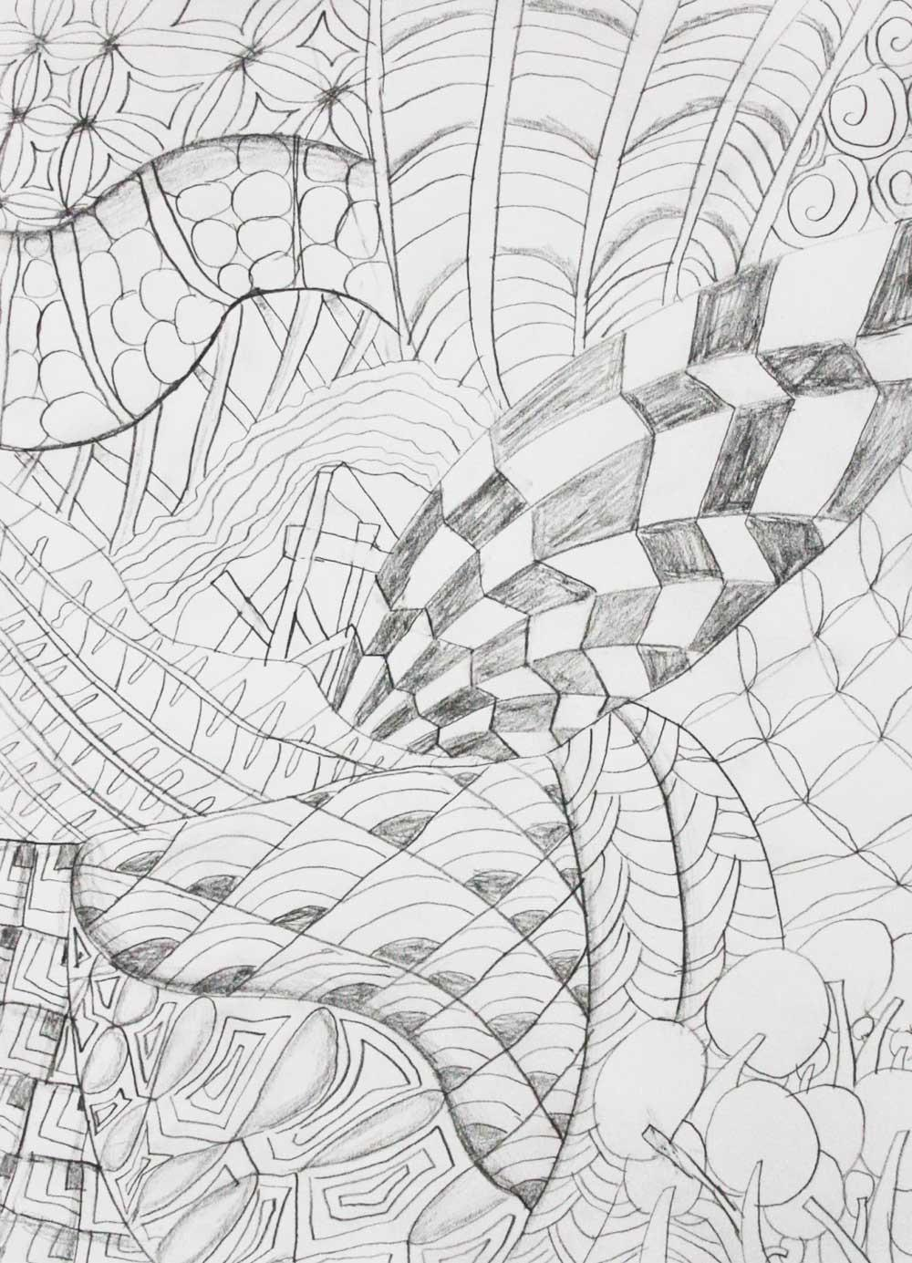
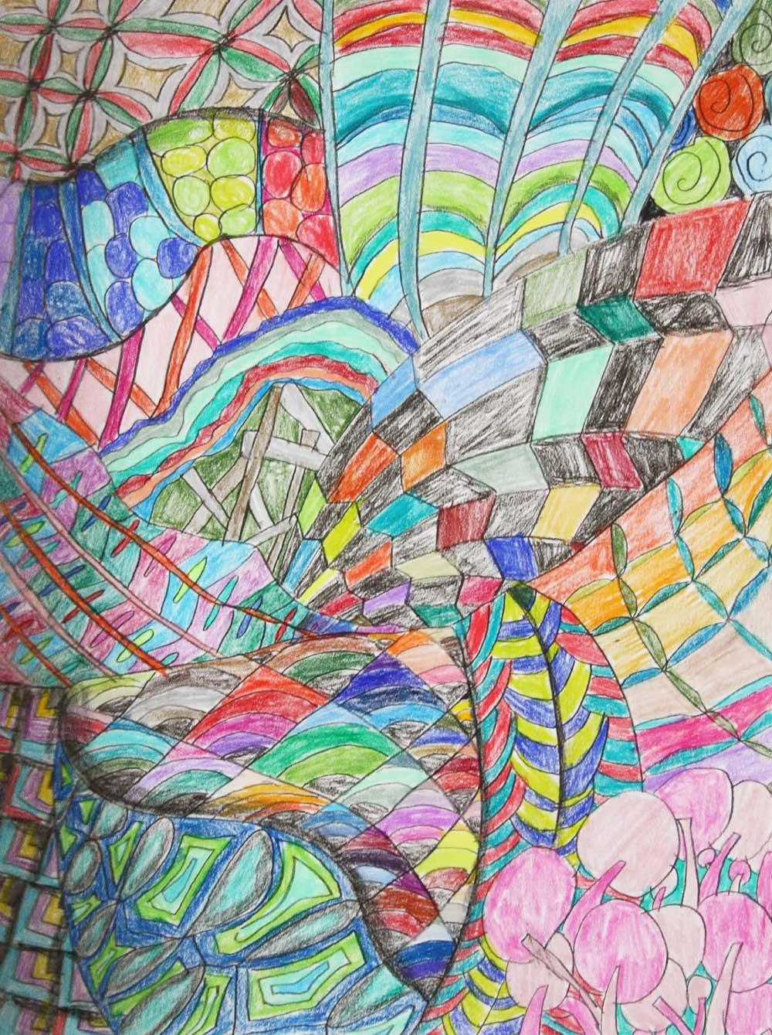
Add some colour if you like:

Hope you all have a good week of work. We are here if you need help with anything.

