5th Class Work
1st – 5th January

Monday | Tuesday | Wednesday | Thursday | Friday
Maths  Master Your Maths-Week 16  Continue with the next day of your Master Your Maths book | Maths  Master Your Maths-Week 16  Continue with the next day of your Master Your Maths book | Maths  Master Your Maths-Week 16  Continue with the next day of your Master Your Maths book | Maths  Master Your Maths-Week 16  Continue with the next day of your Master Your Maths book | Maths  Master Your Maths-Week 16  Friday test
English  Spell It unit 16  Learn your next set of spelling words and do the next 2 activities in your spelling book.  Lift Off  Pg. 104/105 read the story and answer questions 3(a-h) in your copy. | English  Spell It unit 16  Learn your next set of spelling words and do the next 2 activities in your spelling book.  Lift Off  Pg.105  Answer Q 4 a – h . | English  Spell It unit 16  Learn your next set of spelling words and do the next 2 activities in your spelling book.  Lift Off  Pick 10 of your spellings for this week and write a short story using the words | English  Spell It unit 16  Learn your next set of spelling words and do the next 2 activities in your spelling book.  Lift Off  Read page 86 and answer Q 3 a-g in your copy | English  Spell It unit 16  Learn your next set of spelling words and do the next 2 activities in your spelling book.  Lift Off  Pg. 87 Answer Q 7 a-d in your copy .
PE  Skipping Challenge –see below | Irish  Sa bhaile – see below | S.E.S.E  Science experiment. See below | S.P.H.E  Achievements – see below | Art  see below

PE (Do on Monday)

Skipping - any sort of rope will do. I too have been practicing at home and used one of my Dad's old blue ropes he uses to tie things together !

Write down your scores for some fun and see if you can improve by the end of the week. Just try your best.

- See how many you can do in 1 minute

- If you feel you are improving, see how many you can now do with left leg only, then also with your right leg only.

If you are not sure how to do it, click on this link below :)

https://www.youtube.com/watch?v=KYlSiTGD2_I

If you can’t find a rope at home, do the fitness class below with Joe Wicks!
https://www.youtube.com/watch?v=qGKGNzNbWjU

Gaeilge (Do on Tuesday)
- Walk around your house/garden and write down the names of 10 things you have in your house in Irish! You can pick different types of rooms if you like (bathroom) or things youd find in different rooms(press, sink) Don’t pick any of the same things that you picked the last time. Pictures below will give you ideas!
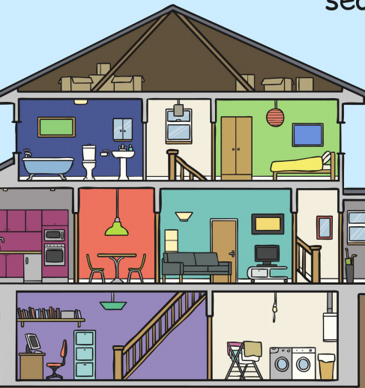
- Complete the Irish wordsearch attached if you have a printer to print it off. If you don’t have a printer, don’t worry about it!

Science (Do on Wednesday)

We sometimes think experiments are tricky to do - but not all of them are !

Click on this and answer the questions after please !

https://www.youtube.com/watch?v=o08jgkut7e8

1 - What is going on in this video ? (2-3 sentences please)

2 - What materials (things) were needed for them to complete this experiment?

3 - With permission from a parent, give it a go for yourself and write down if it worked for you too.

SPHE (Do on Thursday)

Your achievements.

Achievements are things you did that had a lasting impact for you.
Usually, they are things that you created, built, designed, or won.

Q. Write in your copy / page, 6 achievements that you are proud of and explain why.

An example could be
- "I finished cleaning my room this week quicker than usual because I made sure not to be doing anything else at the same time that might have distracted me like being on my phone"
Remember - there is no right or wrong, if you are proud of it then that is enough to put down !

Animal Art (Do on Friday)

There are loads of different drawings to choose from in the link below. Please choose your favourite one, draw and colour it nand then email a picture of your work back if you like. I would love to see what you choose and how you have designed it!

https://www.youtube.com/watch?v=qJNSOte9h4I

If you would prefer to colour (and cut out if you want) some of the pictures below either then that no problem !

