6th Class Work
1st - 5th March

Monday | Tuesday | Wednesday | Thursday | Friday
Maths  Master Your Maths-Week 18  Continue with the next day  Practice your tables (÷2) | Maths  Master Your Maths-Week 18  Continue with the next day  Practice your tables (÷2) | Maths  Master Your Maths-Week 18  Continue with the next day  Practice your tables (÷3) | Maths  Master Your Maths-Week 18  Continue with the next day  Practice your tables (÷2) | Maths  Master Your Maths-Week 18  Complete your Friday Test  Practice your tables (Test Yourself (÷2, ÷3)
English  Spell It  Learn your next set of spelling words and do the next 2 activities in your spelling book.  Ghost, Secrets & thieves  Read pg. 72-75  Lift Off  Read Pg. 38 | English  Spell It  Learn your next set of spelling words and do the next 2 activities in your spelling book.  Ghost, Secrets & thieves  Read pg. 76-80  Lift Off  Pg. 39  Q 3 | English  Spell It  Learn your next set of spelling words and do the next 2 activities in your spelling book.  Ghost, Secrets & thieves  Read pg. 81-83  Lift Off  Pg. 39  Q 4 | English  Spell It  Learn your next set of spelling words and do the next 2 activities in your spelling book.  Ghost, Secrets & thieves  Read pg.84-85  Lift Off  Pg. 40  Q6 | English  Spell It  Learn your next set of spelling words and do the next 2 activities in your spelling book.  Ghost, Secrets & thieves  Read pg. 86-88  Lift Off  Pg. 40  Q 7
PE  Yoga | Irish  Léamhthuiscint- Lúsaí | S.E.S.E  Refraction of light experiment | S.P.H.E  My achievements | Art  How to draw a rhino

Monday: PE
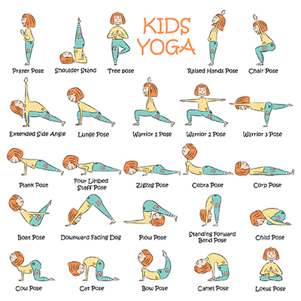
Choose 5 of your favourite yoga poses and put them in a sequence
Repeat this sequence 3 times
Get members of your family to join you!

Tuesday: Irish/Gaeilge
- Read this short passage. Look at the questions in the red box and fill in these blanks-
- L______ is anim di
- Tá sí n_____ mbliana d’aois
- Tá sí ina chonaí i mb____ m____
- Tá b____ deartháireacha aici
- Níl aon pheata aici

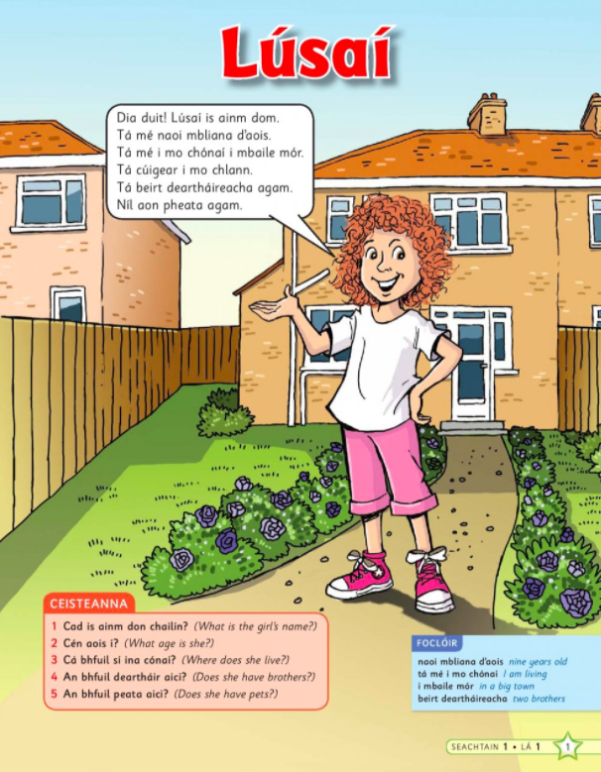

Wednesday:S.E.S.E

Refraction of Light in Water!
We sometimes think experiments are tricky to do - but not all of them are !

Click on this link or copy and paste it into Google and answer the questions after please !

https://www.youtube.com/watch?v=o08jgkut7e8

1 - What is going on in this video ? (2-3 sentences please)

2 - What materials ( things ) were needed for them to complete this experiment ?

3 - With permission from a parent, give it a go for yourself and write down if it worked for you too.

Thursday: SPHE-
Your achievements.

Achievements are things you did that had a lasting impact for you.
Usually, they are things that you created, built, designed, or won.
An example could be
- "I finished cleaning my room this week quicker than usual because I made sure not to be doing anything else at the same time that might have distracted me like being on my phone"
Remember - there is no right or wrong, if you are proud of it then that is enough to put down !

Friday: ART
See if you can draw this rhino! Keep practising and soon you’ll be able to draw one without the guides.
