6th Class Work
22nd - 26th February

Monday | Tuesday | Wednesday | Thursday | Friday
Maths  Master Your Maths-Week 17  Continue with the next day  Practice your tables (x11) | Maths  Master Your Maths-Week 17  Continue with the next day  Practice your tables (x11) | Maths  Master Your Maths-Week 17  Continue with the next day  Practice your tables (x12) | Maths  Master Your Maths-Week 17  Continue with the next day  Practice your tables (x12) | Maths  Master Your Maths-Week 17  Complete your Friday Test  Practice your tables (Test Yourself x11/x12)
English  Spell It  Learn your next set of spelling words and do the next 2 activities in your spelling book.  Ghost, Secrets & thieves  Read pg. 57-59  Lift Off  Pg. 33  Q 4 | English  Spell It  Learn your next set of spelling words and do the next 2 activities in your spelling book.  Ghost, Secrets & thieves  Read pg. 60-62  Lift Off  Pg. 33  Q 5 | English  Spell It  Learn your next set of spelling words and do the next 2 activities in your spelling book.  Ghost, Secrets & thieves  Read pg. 63-65  Lift Off  Pg. 34  Q 6 | English  Spell It  Learn your next set of spelling words and do the next 2 activities in your spelling book.  Ghost, Secrets & thieves  Read pg.66-68  Lift Off  Pg. 34  Q7 | English  Spell It  Learn your next set of spelling words and do the next 2 activities in your spelling book.  Ghost, Secrets & thieves  Read pg. 69-71  Lift Off  Pg. 34  Q 8
PE  Tabata | Irish  Teilifís | S.E.S.E  First man on the moon | S.P.H.E  Positivity Jar | Art  Space Rocket

Monday: PE
Tabata-
full body work out
Instructions
- Start with the 1st exercise,
- work for 20 seconds, then rest for 10 seconds
- Do this 6 times before you are allowed to move onto exercise number 2 & so on.
- Star jumps | 20 seconds on/ 10 seconds rest -repeat x6
30 second rest
- Plank | 20 seconds on/ 10 seconds rest -repeat x6
30 second rest
- High Knees | 20 seconds on/ 10 seconds rest -repeat x6
30 second rest
- Press up from knees | 20 seconds on/ 10 seconds rest -repeat x6
30 second rest
- Sprints | 20 seconds on/ 10 seconds rest -repeat x6
30 second rest
- Plank shoulder taps | 20 seconds on/ 10 seconds rest -repeat x6
Extra- Grumpy Jacks- Everytime somebody in your household complains, stand up & do 10 jumping jacks and then just sit back down. Don’t tell them what you’re doing & see if they have figured it out by the end of the day.
Tuesday: Irish/Gaeilge
cartún | clár grinn | clár dúlra | trath na gceist
clár spóirt | clár cainte | nuacht | clár ceoil
sobaldráma | teilifís réaltachta | scannán | cúrsaí reatha
Take a look at all the programmes that you and your family might be watching at this time. Write down what programmes you like, what programmes you don't like and what programmes you prefer. You can use the website www.focloir.ie to help you.
Activity 1: 👍 Is maith liom ________.
👎 Ní maith liom ________.
👌 Is fearr liom _________.
Activity 2: (If you need an extra challenge) Write down when the programme is on.
Mar Shampla: Tá cartún ar siúl ar a trí a chlog Dé Luain.

Wednesday:S.E.S.E
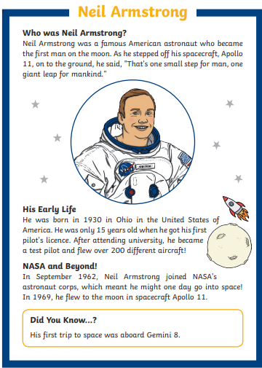

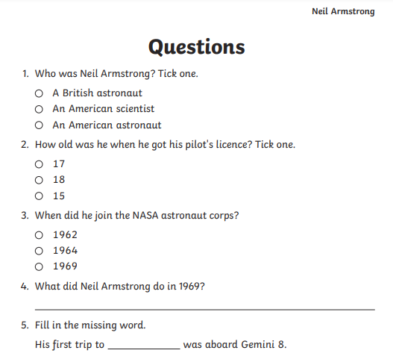

Thursday: SPHE-
Positivity jar
Find an old jar or tub in your house. Each day write down something you are grateful for/ something positive that happened. Post them in to the jar. You can do this alone or with you family. If you ever feel upset/ down / sad/ read some of the posts in the jar to remind you of happy things.
Friday: ART
Space Rockets- design you own 3D or 2D rocket to fly into outer space using clean recycling items like empty cereal boxes etc.
