6th Class Work
8th – 12th March

Monday | Tuesday | Wednesday | Thursday | Friday
Maths  Master Your Maths-Week 19  Continue with the next day  Practice your tables (÷4) | Maths  Master Your Maths-Week 19  Continue with the next day  Practice your tables (÷4) | Maths  Master Your Maths-Week 19  Continue with the next day  Practice your tables (÷5) | Maths  Master Your Maths-Week 19  Continue with the next day  Practice your tables (÷5) | Maths  Master Your Maths-Week 19  Complete your Friday Test  Practice your tables (Test Yourself (÷4, ÷5)
English  Spell It  Learn your next set of spelling words and do the next 2 activities in your spelling book.  Ghost, Secrets & thieves  Read pg. 89-91  Lift Off  Read Pg. 44 | English  Spell It  Learn your next set of spelling words and do the next 2 activities in your spelling book.  Ghost, Secrets & thieves  Read pg. 92-94  Lift Off  Pg. 45 Q. 3 | English  Spell It  Learn your next set of spelling words and do the next 2 activities in your spelling book.  Ghost, Secrets & thieves  Read pg. 95-97  Lift Off  Pg. 44 Q 4 | English  Spell It  Learn your next set of spelling words and do the next 2 activities in your spelling book.  Ghost, Secrets & thieves  Read pg. 98-100  Lift Off  Pg. 44 Q 5 & 6 | English  Spell It  Learn your next set of spelling words and do the next 2 activities in your spelling book.  Ghost, Secrets & thieves  Read pg. 101-103  Lift Off  Pg. 45 Q8
PE  Joe Wicks Video | Irish  Bun go Barr | S.E.S.E  Climate: Altitude | S.P.H.E  Friendship | Art  Drawing Landmarks

Monday: PE
Click on the link below and take part in an 8 minute Joe Wicks workout! https://www.youtube.com/watch?v=EXt2jLRlaf8

Tuesday: Irish/Gaeilge
Read the piece below and answer questions 1-6 of part B.
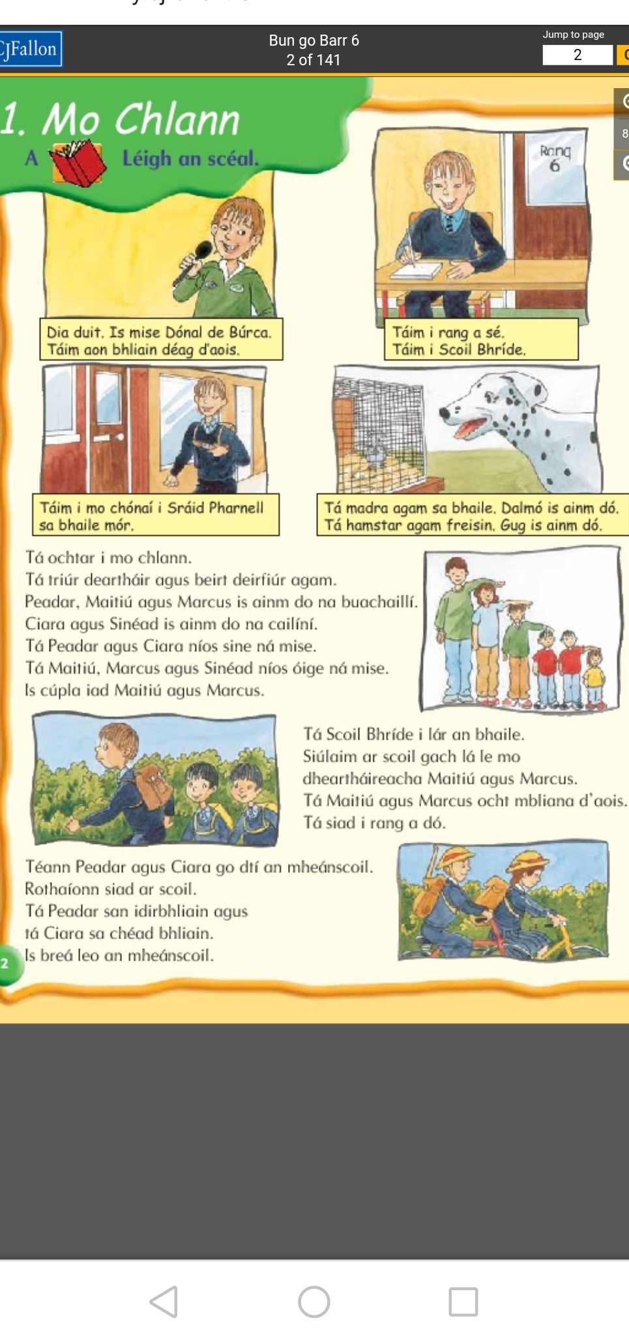
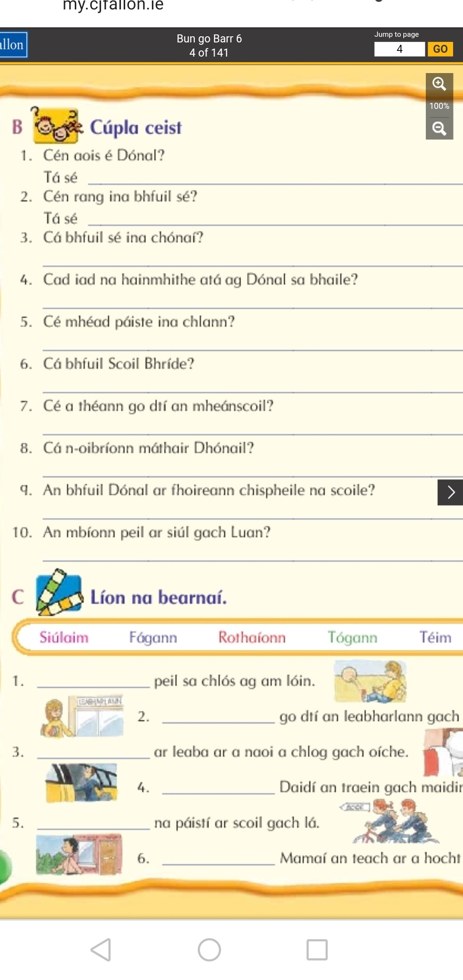
Wednesday:S.E.S.E
Climate – Altitude

Click on this link or copy and paste it into Google and answer the questions after please!

https://www.youtube.com/watch?v=ZgzEsKBmXew

1. What Is the difference between climate and the weather?
2. What Is altitude?
3. How does altitude affect the climate?
4. What Is the highest altitude point on earth?

Thursday: SPHE

Friendship
- These difficult times have made us realise the Importance of friends In our lives because we can't see them as often. Write a short piece on the Importance of friends and what makes a good friend.

Friday: ART
After completing reports on a Country of your choice last week, It might be a nice Idea to add a drawing of a famous landmark to go with It. Here are some examples below. If you want to learn how to draw one that Isn't here, just type In 'step by step guide to drawing ____' In google Images and you can get great help there. Good luck!
