22nd – 26th February
Hi Boys and Girls,

I hope that you all had a lovely Mid-Term Break. I have included your reading work for this week below. These readings should be done instead of the Read at Home. Read each story and answer the questions in your copy.
Keep up the great work,

Ms. Nolan

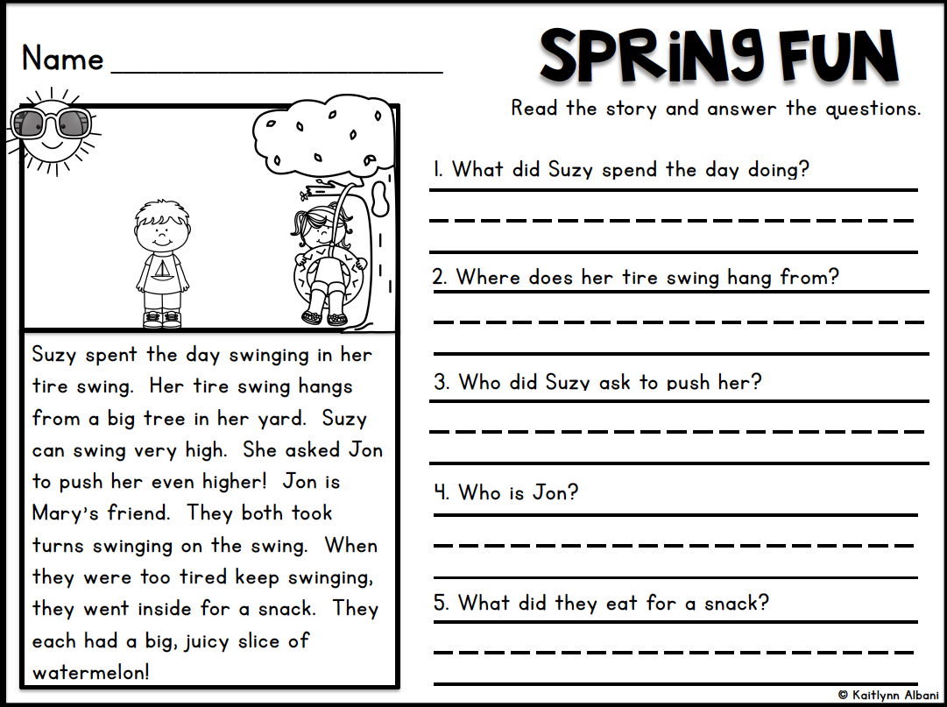
Monday 22nd February

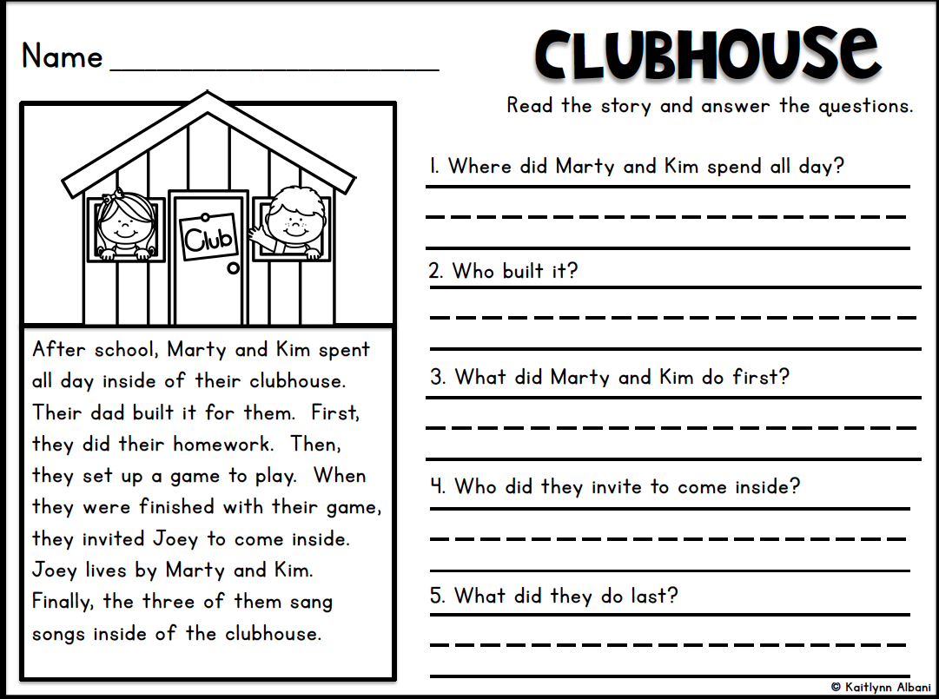
Tuesday 23rd February

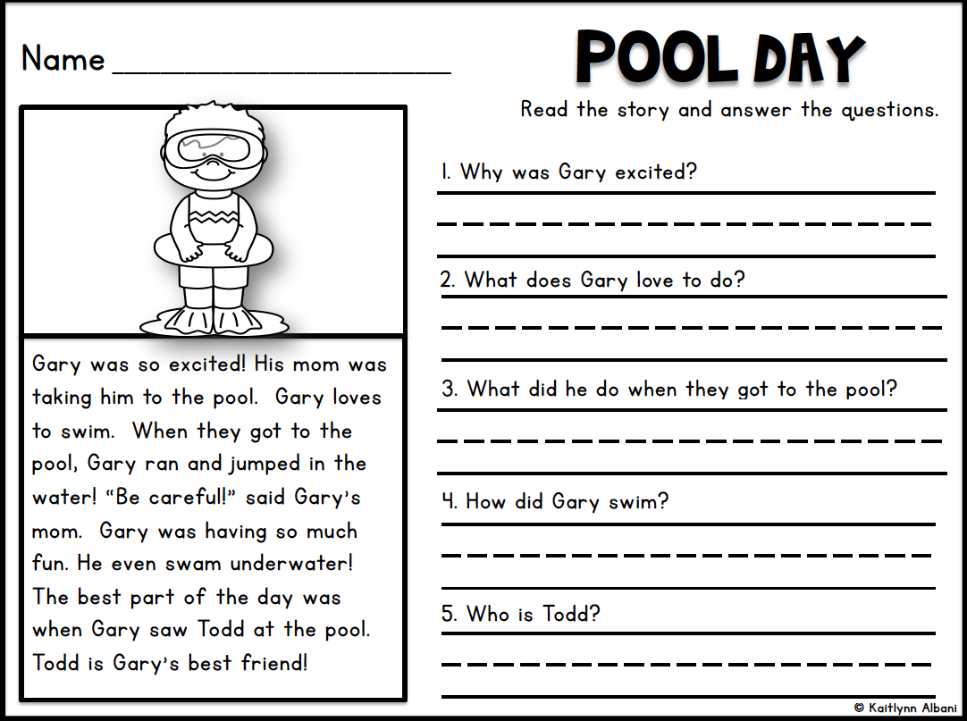
Wednesday 24th February

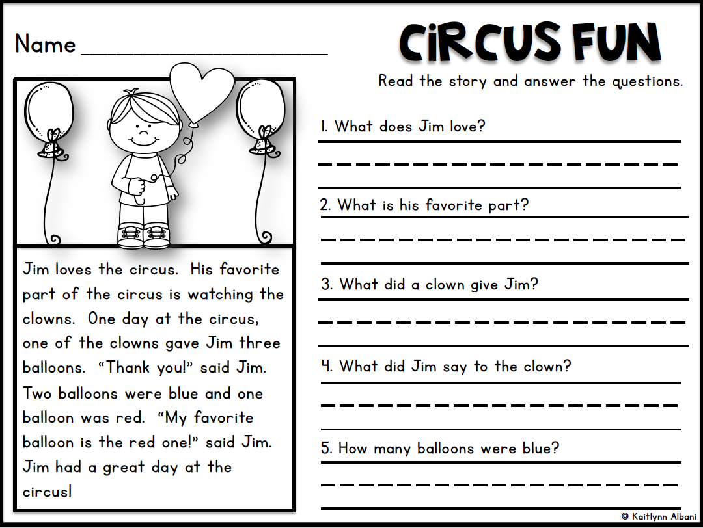
Thursday 25th February

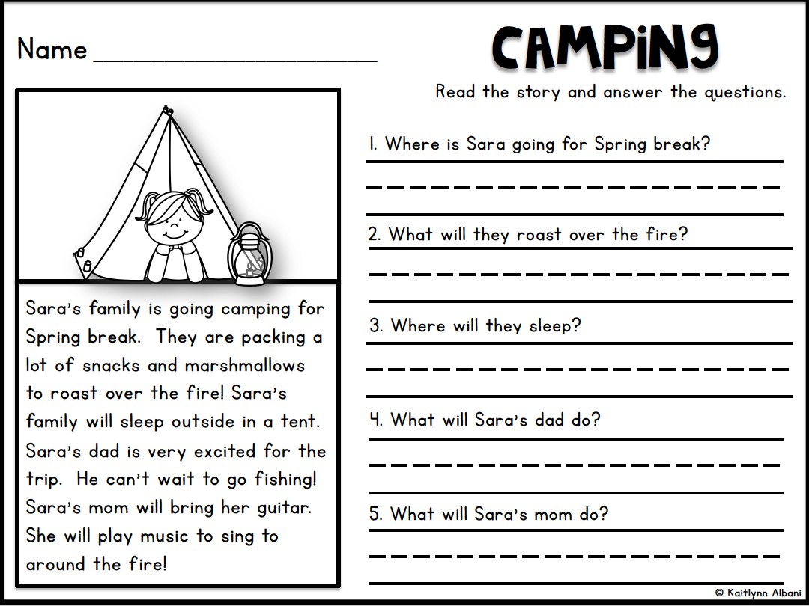
Friday 26th February

