8th- 12th February
Hi Boys and Girls,

I hope that you are all well. I have included your reading work for this week below. These readings should be done instead of the Read at Home. Read each story and answer the questions in your copy.
Keep up the great work,

Ms. Nolan

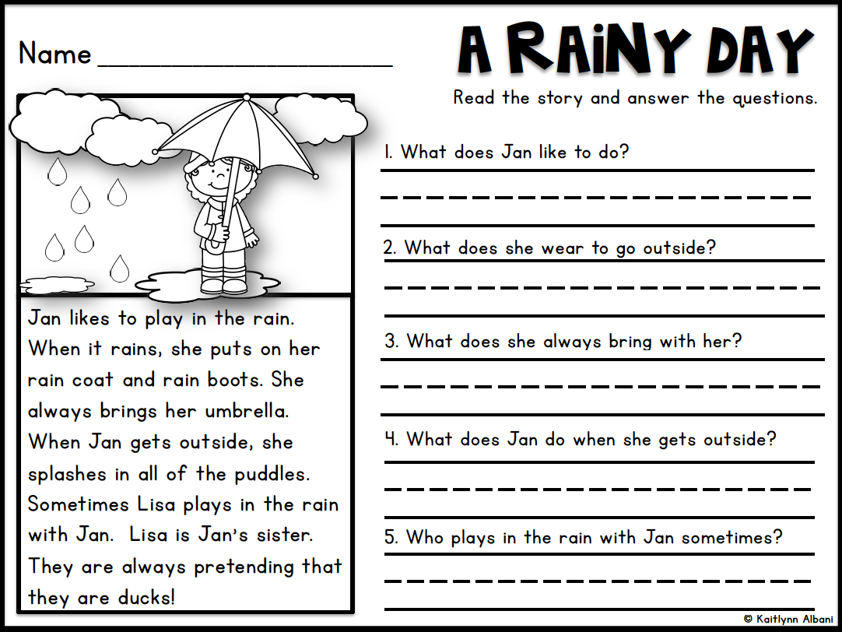
Monday 8th February

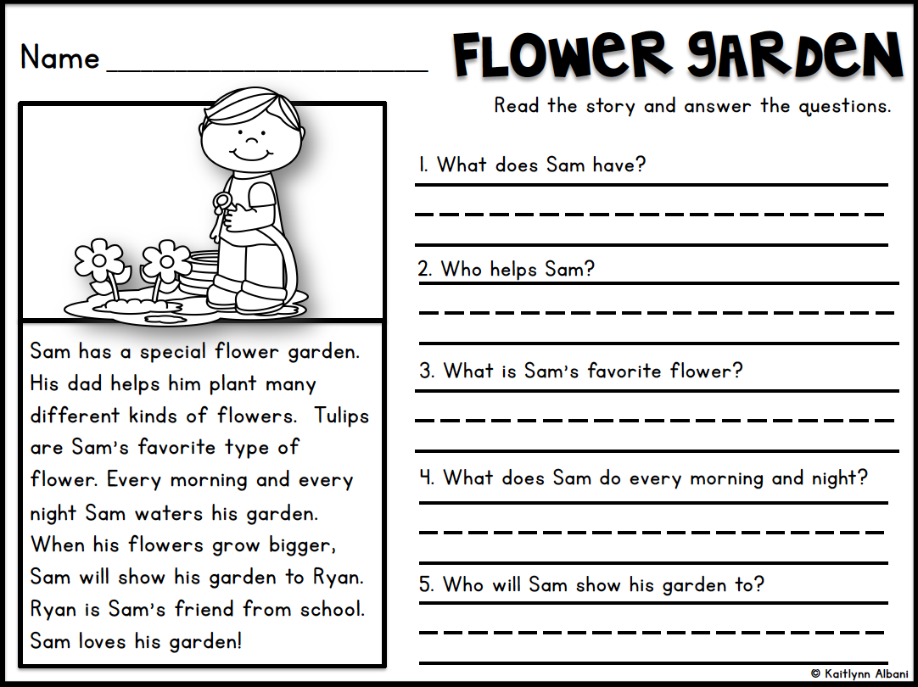
Tuesday 9th February

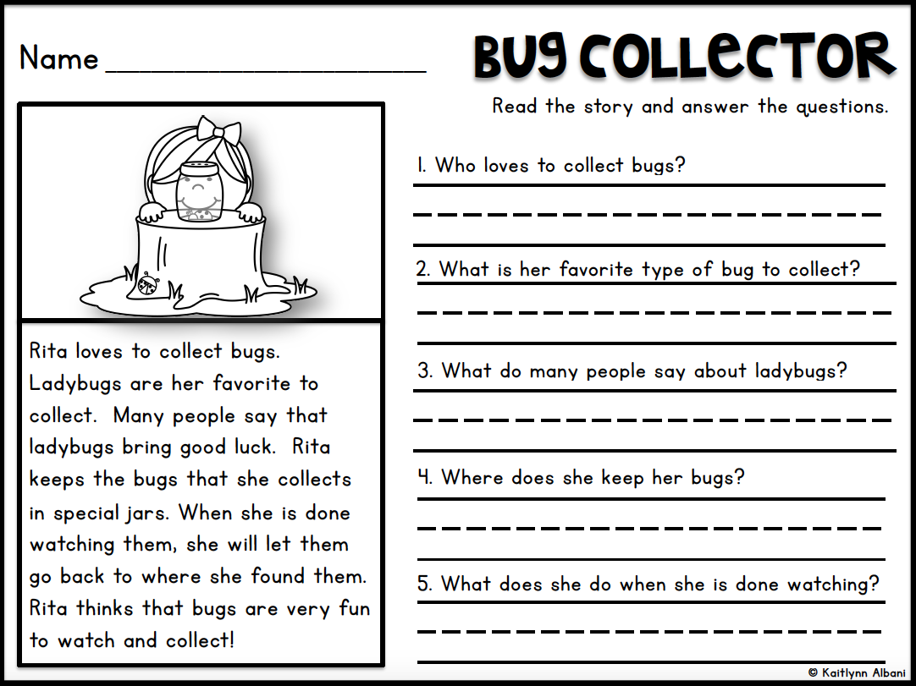
Wednesday 10th February

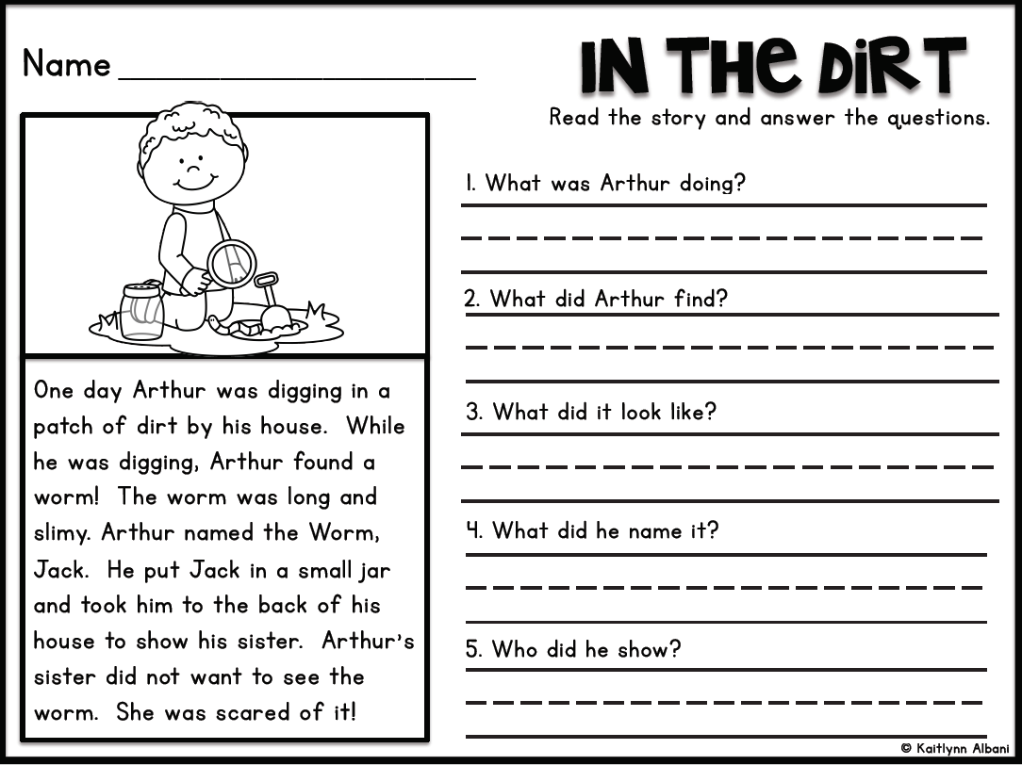
Thursday 11th February

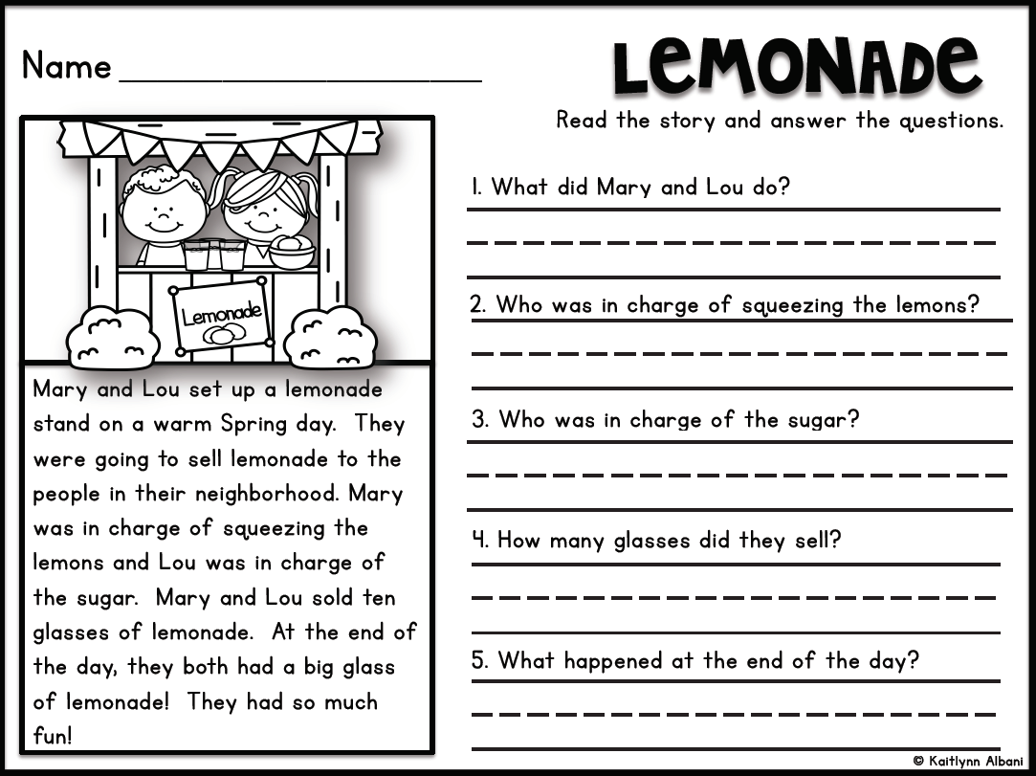
Friday 12th February

