Respiratory System: The System we Use to Breathe
Remember: Always ask an adult’s permission before using the internet
- Type ’ respiratory system peekaboo kidz’ into ‘You Tube’ and watch the 4 minute video on the respiratory system.
- If you don’t have a printer just draw the outline of the picture below in your copy. Next draw in the parts of the respiratory system seen below and label them.

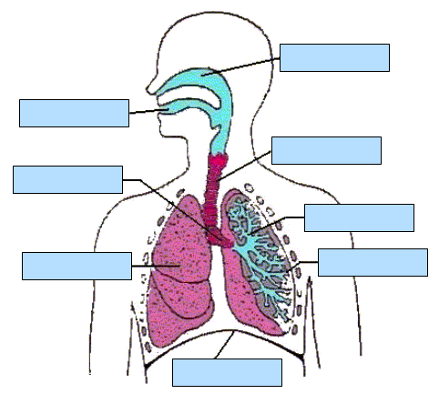

These are difficult words to say! In the red brackets I’ve written how they sound. Practice with an adult. The words in black are the correct spellings. Use them to label your respiratory system.
- alveoli (al- vee- ow- lai)
- bronchi (bron –kee-owls)
- bronchioles (brong- key – owlz )
- diaphragm (die – a –fram)
- lung
- mouth
- nasal passage (nose)
- trachea (track – e –a )

