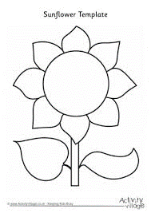
Art Instructions : Sunflowers by Van Gogh
Art Materials
- Flat piece of cardboard, back of a cereal box
- Yellow, brown, blue and orange paint (other colours if your like)
- paintbrush
- PVA glue, some people will already have this in their house for making slime
- Household ingredients to add texture to the paint e.g. washing powder, seeds, rice, flour or porridge oats
Method
- Draw a large sunflower on your piece of card, use this picture as a guide
- Mix the paints with some of the household ingredients listed above to create texture. Add in the PVA glue to hold it all together. For example, mix the yellow paint with washing powder and PVA glue then mix the brown paint with seeds or porridge oats and PVA glue.
- Like Van Gogh did, use some utensils such as a paintbrush, fork or spoon to spread your textured paint thinly onto your picture.
- Paint the background with regular paint to make your sunflower pop!
- Leave to dry for 24-48 hours
- When it’s dry, paint over it lightly with the PVA glue. This will help to stop your work of art flaking.
Top Tip
Don’t spread textured paint too thickly as it will not dry properly. Try out different colours and materials, be creative.

Well Done,
You have used the impasto technique to create your own piece of art.
I would love to see it, email me a picture if you can.

