5th Class Work
1th – 5th Feb

Monday | Tuesday | Wednesday | Thursday | Friday
Maths  Master Your Maths-Week 19  Continue with the next day of your Master Your Maths book | Maths  Master Your Maths-Week 19  Continue with the next day of your Master Your Maths book | Maths  Master Your Maths-Week 19  Continue with the next day of your Master Your Maths book | Maths  Master Your Maths-Week 19  Continue with the next day of your Master Your Maths book | Maths  Master Your Maths-Week 19  Friday test
English  Spell It unit 19  Learn your next set of spelling words and do the next 2 activities in your spelling book.  Reading  Read the 1st reading in the reading pack and do questions | English  Spell It unit 19 Learn your next set of spelling words and do the next 2 activities in your spelling book.  Reading  Read 2nd reading in the reading pack attached and do questions | English  Spell It unit 19  Learn your next set of spelling words and do the next 2 activities in your spelling book.  Reading  Pick 10 of your spellings for this week and write a short story using the words | English  Spell It unit 19  Learn your next set of spelling words and do the next 2 activities in your spelling book.  Reading  Read 3rd story in the reading pack and do questions | English  Spell It unit 19  Learn your next set of spelling words and do the next 2 activities in your spelling book.  Reading  Read 4th story in the reading pack and do questions
PE  –see below | Irish  see below | S.E.S.E  See below | S.P.H.E  see below | Art  see below

PE (Do on Monday)

Go onto go noodle and do one or two of the dances on it.

Irish

Write down as many pass times in Irish as you can. For example, tennis, football.

SESE Geography (Do on Wednesday)

- SESE: Choose from one of the below topics (45-60 minutes). Write a report based on your research. Yes, penmanship and spelling matters so do your best. One topic may take more than one day.

    - Atlas Hunt Activities (World Geography)
    - Research country of interest
    - Irish Myths and Legends
    - Georgian Dublin
    - Research a person you admire
    - Famous World Landmarks
    - Unusual animals
    - Project work- Pick a country of your choice (outside of Europe). Some of the headings may include : Physical features (Mountains rivers), political (cities towns), tourism, industry, famous people, other
    - Anything that interests you

SPHE (Do on Thursday)
Write down the phrases below in order of what is more importance to you.

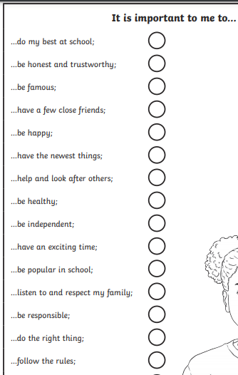

Art (Do on Friday)

Make an uplifting poster with a message that will help people who are feeling lonely at this time. You can display it on your window or send it to family and friends.

