1st – 5th March
Hi Boys and Girls,

I hope you had a lovely weekend. I have included your reading work for this week below. These readings should be done instead of the Read at Home. Read each story and answer the questions in your copy.

Ms. Nolan

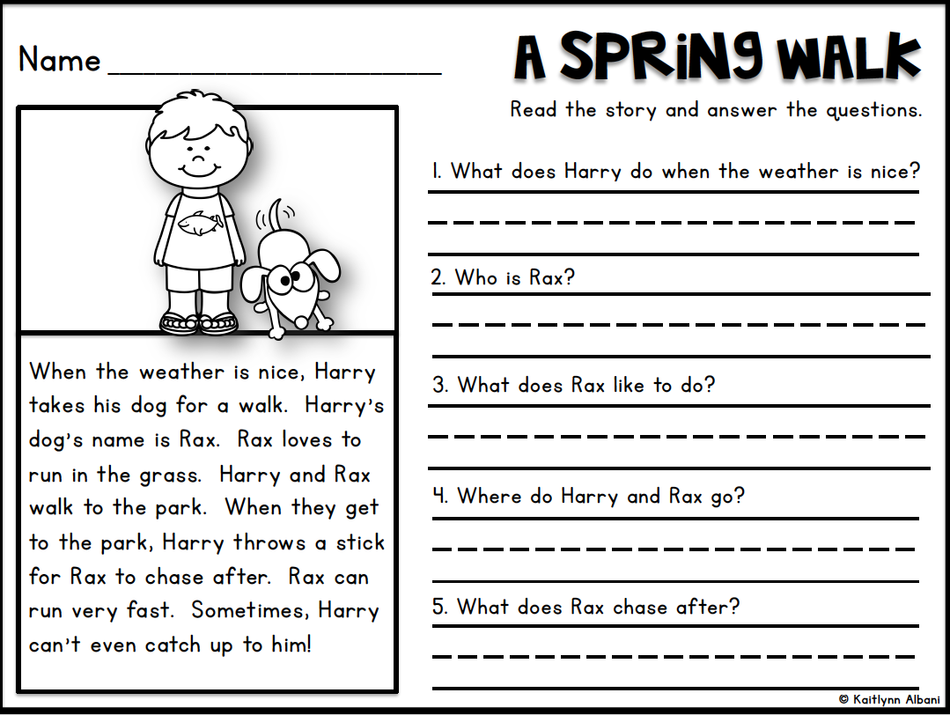
Monday 1st March

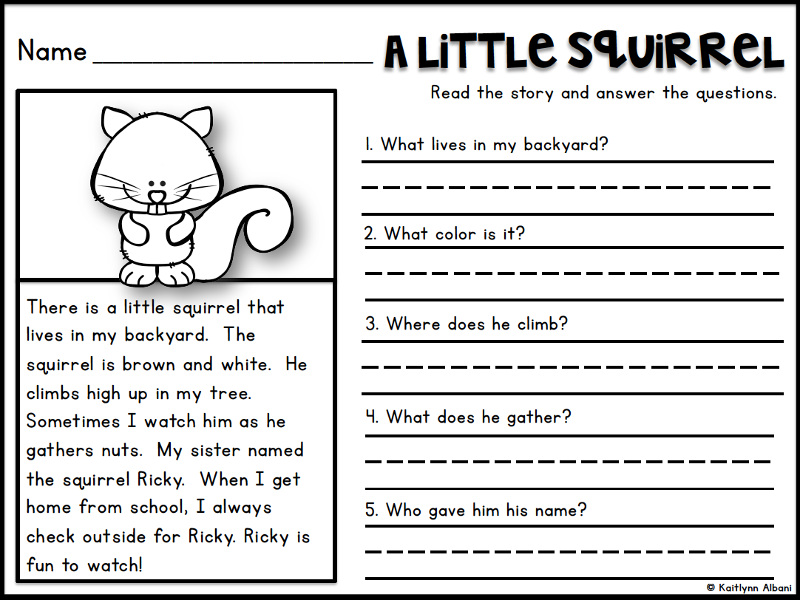
Tuesday 2nd March

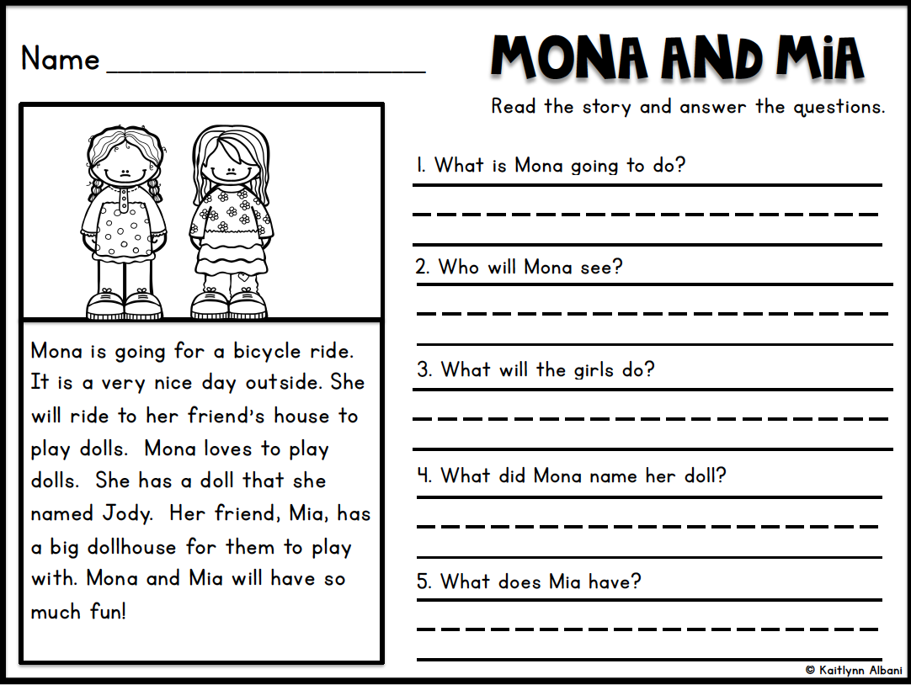
Wednesday 3rd March

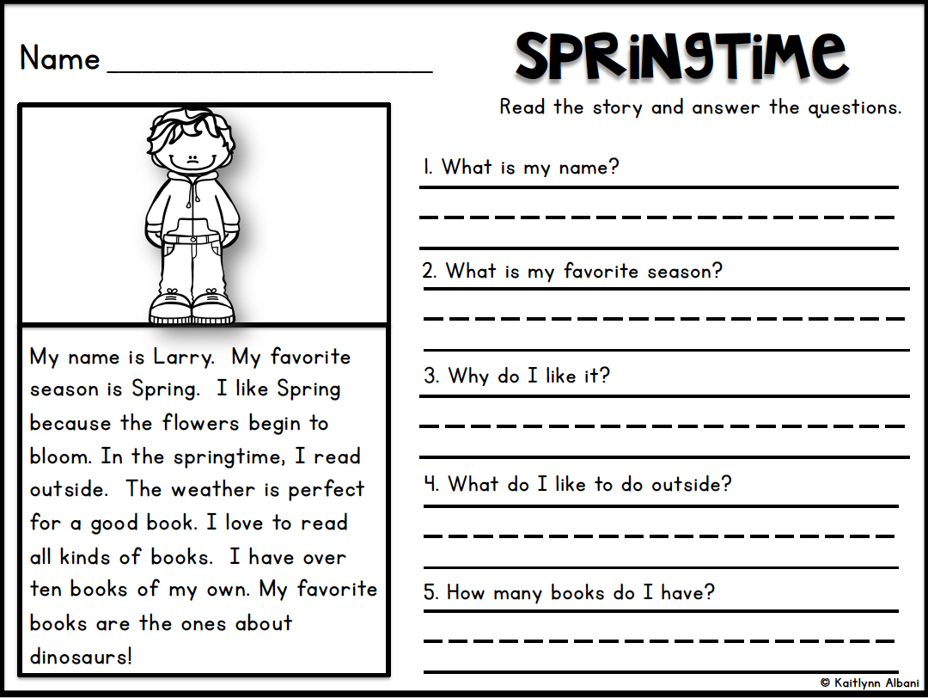
Thursday 4th March

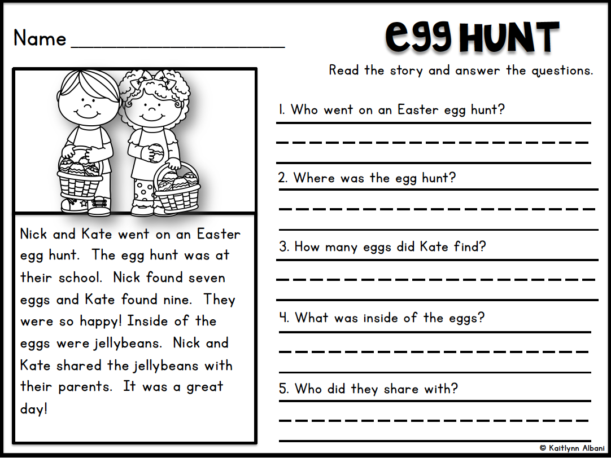
Friday 5th March

