8th – 12th March
Hi Boys and Girls,

I hope you all enjoyed the sun over the weekend. This is your reading work for this week. I am looking forward to seeing you all very soon!
Ms. Nolan

Monday 8th March
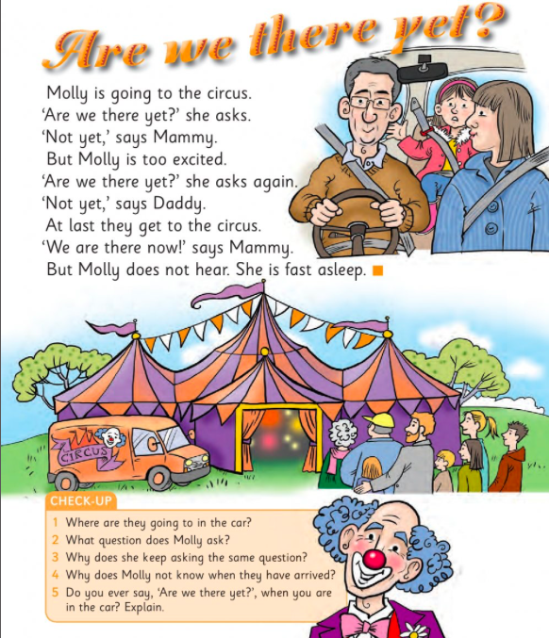
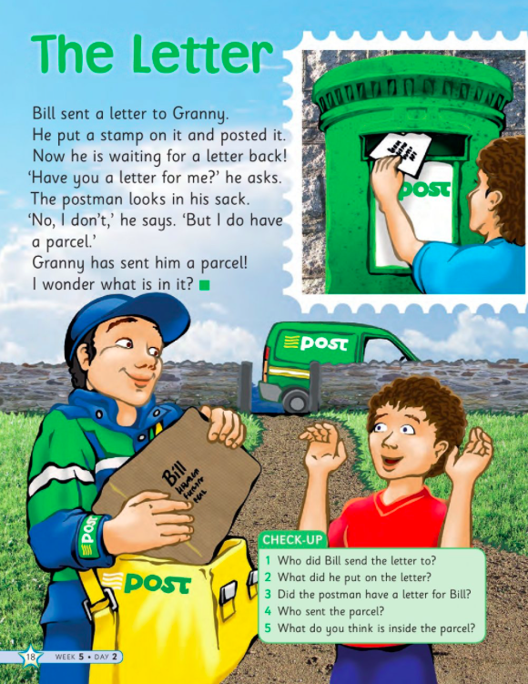
Tuesday 9th March

Wednesday 10th March

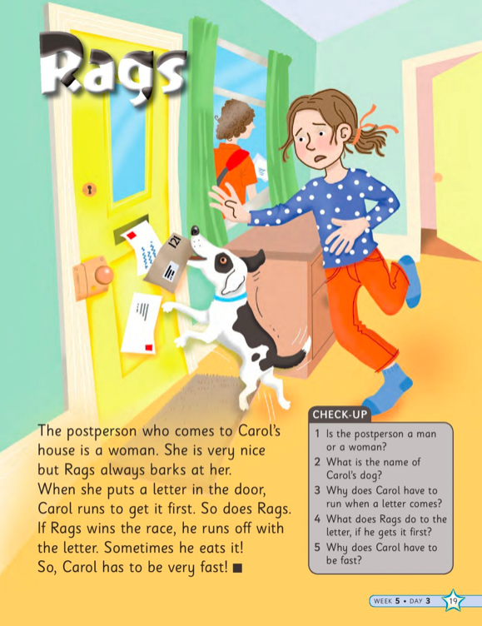

Thursday 11th March
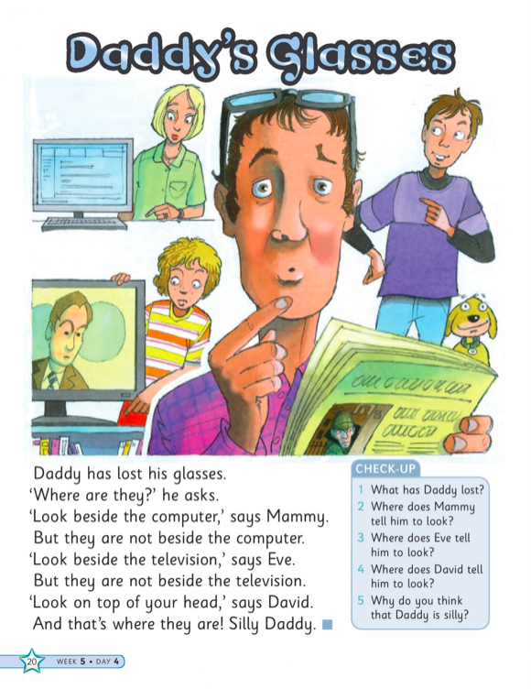

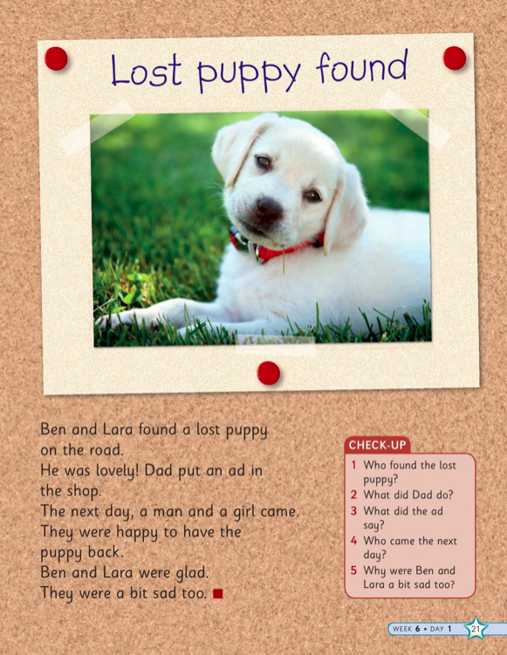
Friday 12th March

